Presents
Stanza

TRANSPARENCY: THE ARTISTS STUDIO AS LABORATORY FOR THE FUTURE

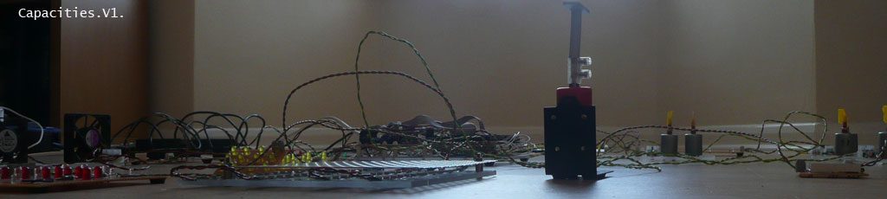

Monday 26 July until Friday 27 August 2010

Over the summer, Stanza is working in the Barn at Lanternhouse, to create cityscapes in an Open Studio process. He will be creating a cityscape covering the floor of the Barn. The work is about exploring the artistic process, being transparent about the process and the development and production of new work.

During the creation process, Stanza will reveal the architecture of creation. He will reveal the actual process; lay bare the reality of the work, physically by showing the machinery of the piece in progress and theoretically with a series of show-and-tell invitations to the public.

This is a new way of using the Barn as a studio and the project is helping Lanternhouse make more sense of the building and how spaces are utilised.
In this way, the “open studio” mirrors the process of the project, with material and philosophical process being available to witness throughout.
Stanza is documenting his work and it will be available online for audience and participants to follow. The Barn is an Open Studio, a public domain space possibly with a live CCTV link available online at www.stanza.co.uk and via the Lanternhouse site on www.lanternhouse.org

This is not the creation of a visual exhibition: this is an open process with the development and production of work so no photography please.

There are three works being developed:
- Sonicity
- Capacities
- Open Studio: Transparency

Sonicity
http://www.stanza.co.uk/sonicity/index.html

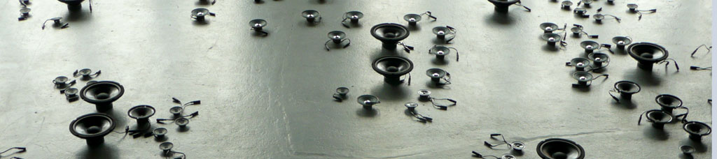

Sonicity is a responsive installation, a sonification of the data space. The sounds you hear are the sounds of the changing environment, the changes of noise, light, temperature of the space turned into a real time sound stream using dozens of wireless sensors.
This project investigates the real time space and the experience of the gallery visitor as they interact with the space, using data gathered from new technologies. The system monitors the space (the building) and the environment (the town) and captures live real time data (light, temperature, noise, humidity, position) to create an ambient sonification, an acoustic responsive environment, literally the sound of the micro incidents of change that occur over time.

Capacities
http://www.stanza.co.uk/capacities/

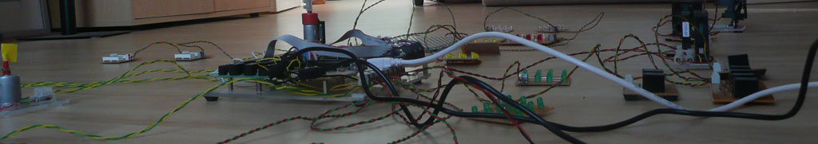

The installation is about the real time city, making artworks using live data. Essentially this artwork gathers data from the city which is then made virtual. This data is represented as an electronic city. Data is manipulated and that ‘powers’ all the ‘events’ in the installation. The changing data affects all the changes one experiences in the space. These are the moving objects, fans and changing lights all responding to changes in temperature, light, pressure, noise, and the sound of the space.

The objective is to explore new ways of thinking about interaction within public space using data gathered from new technologies. Motes are used to collect the data. Motes are tiny wireless sensor boards that gather data and communicate to the central server. The real world is monitored and the data stored in an archive retrieval system. Motes and sensor boards sense the micro incidents of change in the light, the noise, temperature and sounds of the flows inside the space.
Key themes of the work are: networking, real time, responsive, mediated, online, dataspace, city, artwork.
Transparency

Transparency is the whole work, the Open Studio process as artwork which can be witnessed online or live, here at Lanternhouse

Participation

Stanza’s work is process as exhibition, with opportunities for participants and audience to see the artwork unfold and then to see the final piece from Monday 23 – Friday 27 August 2010.

The artist’s website www.stanza.co.uk will be used as a showing space for the final piece and there is a link from the Lanternhouse website to Stanza’s site. www.lanternhouse.org

You can meet Stanza through the six week period, as the work develops. There is also the chance to engage with the development and be involved practically in building the city. Talk to Emma Bartlet here at Lanternhouse.

Volunteer opportunities include painting of large canvases from projections and the chance help with some of the technical aspects of A City of Dreams including rigging projectors and some soldering.

This is a fantastic opportunity to;
- work alongside an exciting International artist
- gain valuable artistic and technical experience
- learn new skills and build on existing skills
- Gain experience that will look great on a CV and in University applications
The hours are flexible and no previous experience is needed to volunteer on this project, just the willingness to get involved in, and help out with the development of Stanza’s great work.

Free event: Meet the Artist
Join us for a glass of wine and an evening with Stanza on Thursday 26 August at 7.30. Stanza will give a brief talk about his work and then there will be the opportunity to ask questions and talk with him.

Stanza writes about previous versions of Transparency:

At an open studio at Goldsmiths College, I carried out various artistic experiments. I also invited Charlie Gere and had conversations with Janis Jefferies and discussed my idea of transparency (a reversal of the panoptican where everything is watched from one perspective now and everything is transparent from all perspectives and available across networks. Everything is transparent: My studio became the open process studio … laboratory. I tried this out in Plymouth in situ in 2008 as a Public Domain Studio and made a variety of works, working in the gallery and created a public domain studio as a laboratory and experimental space.

This work (the studio as lab) is now in version three for my work at Lanternhouse (UK) this summer 2010.

I am developing the idea of studio as laboratory and extending previous versions by inviting members of the public to be involved in the process making and the experiments. The studio will also have live CCTV broadcast and live data feeds.

Artists are like scientists in that they ask questions and find answers in peculiar ways, guided by research and process development. Most artists, like scientists, do stuff and make things to question the world.
They often speculate, the way I see it is that they research difficult issues in a general direction with specific outcomes, these outcomes may or may not be art.

From the real to virtual and back to the real is a theme that has had my attention for five years and the idea is embedded in the works I am currently making.

Transparency, as used in the humanities and in a social context more generally, implies openness, communication, and accountability. It is a metaphorical extension of the meaning. A "transparent" object is one that can be seen through. Transparent procedures include freedom of information legislation.
Sketches in studio and other works based on networks.

About Stanza

Stanza is an internationally recognised artist, who has been exhibiting worldwide since 1984. His artworks have won prestigious painting prizes and ten first prize art awards including:- Vidalife 6.0 First Prize. SeNef Grand Prix. Videobrasil First Prize. Stanza’s art has also been rewarded with a prestigious Nesta Dreamtime Award, an Arts Humanities Creative Fellowship and a Clarks bursary award.
His artworks have been exhibited globally with over fifty exhibitions in the last five years including:- Venice Biennale: Victoria Albert Museum: Tate Britain: Mundo Urbano Madrid: New Forest Pavilion Artsway: State Museum, Novorsibirsk. Biennale of Sydney, Museo Tamayo Arte Contemporáneo Mexico: Plymouth Arts Centre: ICA London: Sao Paulo Biennale.
His mediums include; painting, video, prints, generative artworks and installations. Stanza is an expert in arts technology, CCTV, online networks, touch screens, environmental sensors, and interactive artworks. Recurring themes throughout his career include: the urban landscape, surveillance culture and alienation in the city.

Artistic Statement

I am researching data within cities and the built environment and how this can be represented, visualized and interpreted. Data from security tracking, traffic, and environmental monitoring can all be interpreted as a medium to make artworks. I am investigating new ways of comparing, conceptualizing and then visualizing complex concepts related to the relationship of emergent data and real space in the built environment. Through practice based research, a series of modular experimental artworks are being created to express the possibilities for our data-mediated future.
There are three strands of my working process; these involve collecting the data, visualizing the data, and then displaying the data. The outputs from the online interfaces and online visualisations are now realised as real time dynamic artworks as diverse as installations, and real objects, made out of new display materials back in physical space.
In all my work I try to exploit the changing dynamics of city life as a source for creativity and create meaningful artistic metaphors. I utilise new technologies and integrate new media artworks into the public domain as part of this ongoing research into the visualization of city space. In essence I am researching data as a medium for creativity and how meaningful experiences of our cities may result.
By investigating these data structures I aim to create new metaphors relevant to the experience of the environment. The patterns we make, the visual and imaginative interpretations we give to real world events, are already being networked into retrievable data structures that can be re-imagined and source for information. These patterns disclose new ways of seeing the world. The value of gathering and re-presenting this data in artistic form, and then analysing its’ impact and influence, lies in making meaning accessible to a wider audience.

© Copyright Stanza 2010
www.stanza.co.uk
email: stanza at sublime.net

T ⁺⁴⁴ (0)1229 581127
F ⁺⁴⁴ (0)1229 581232
www.lanternhouse.org
welcome@lanternhouse.org
Lanternhouse, The Ellers, Ulverston, Cumbria, LA12 0AA
Registered in England & Wales Company No. 1095298
Registered Charity No. 265461

